Project Report: "MOJO DOJO" - A Java-Based Text Editor Website\*\*

Student Name: Saksham Jain, Sudeepti Gupta, Jay Singh

Student Regd. No and Batch: 41 (E23CSEU1207, E23CSEU1202, E23CSEU1228)

Course: CSET109

Lab Instructor: Pr. Anjum Mohd Aslam

Submission Date: 18-4-2024

\*\*Abstract:\*\*

"MOJO DOJO" is a text editor website developed using Java technologies such as Swing, HTML, Servlet, and Spring Boot. The project allows users to edit text in various formats and select files from their desktop. Additionally, users can log in using any kind of ID for data management purposes. The website also features an AI chatbot for assistance with editing tasks, although this feature is currently under development. Furthermore, a subscription feature has been implemented, albeit not fully functional at present.

\*\*1. Introduction\*\*

\*\*1.1 Background:\*\*

In the digital age, text editing is a fundamental task for individuals and professionals alike. "MOJO DOJO" aims to provide a user-friendly platform for text editing accessible via web browsers.

\*\*1.2 Problem Statement:\*\*

The project addresses the need for a versatile text editor accessible through web browsers, enabling users to edit various file formats conveniently.

\*\*1.3 Objectives:\*\*

- Develop a web-based text editor using Java technologies.

- Implement user authentication for personalized user experiences.

- Integrate AI chatbot functionality for user assistance.

- Incorporate subscription features for premium user benefits.

\*\*2. Methodology\*\*

\*\*2.1 Tools and Technologies Used:\*\*

The project utilizes Java Swing for the graphical user interface, HTML for web content, Servlet for server-side processing, and Spring Boot for web application development. Other Java libraries and frameworks are employed as needed for specific functionalities.

\*\*2.2 Project Design:\*\*

The design includes a client-server architecture where the server handles user requests and processes text editing tasks. User authentication is managed through secure login procedures, and the AI chatbot interacts with users to provide assistance.

\*\*2.3 Implementation Details:\*\*

The implementation involves integrating Java Swing components for the text editor interface, Servlet for handling HTTP requests, and Spring Boot for web application configuration. User authentication mechanisms are implemented using secure protocols, and AI chatbot integration is in progress.

\*\*3. Results and Discussion\*\*

\*\*3.1 Project Outcomes:\*\*

The project delivers a functional text editor accessible via web browsers, allowing users to edit various file formats and manage their content conveniently. User authentication ensures data security and personalization.

\*\*3.2 Challenges Faced:\*\*

Challenges encountered during the project include integrating diverse Java technologies, implementing secure authentication protocols, and developing the AI chatbot functionality. These challenges were addressed through thorough research and collaboration.

\*\*3.3 Learnings and Insights:\*\*

Working on the project provided valuable insights into Java web development, including UI design, server-client communication, and security practices. Collaborating with team members enhanced problem-solving skills and project management abilities.

\*\*4. Conclusion\*\*

The "MOJO DOJO" project demonstrates the feasibility of developing a Java-based text editor website with advanced features such as user authentication and AI assistance. While some features are still under development, the project lays a solid foundation for future enhancements and improvements.

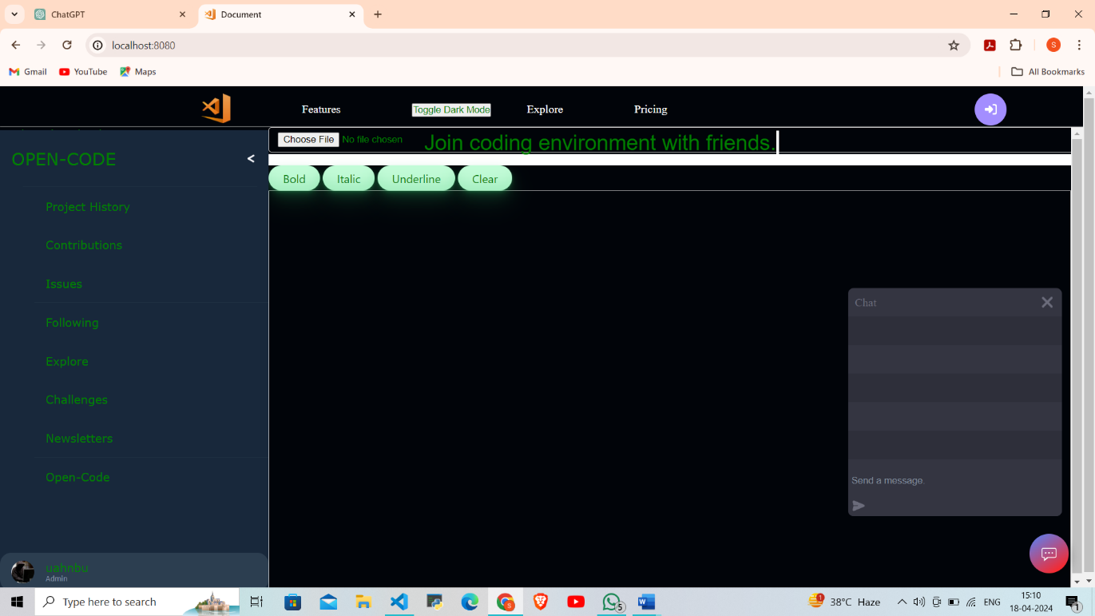\*\*Appendices:\*\* s